**Analysis of User Behavior, Cooking Preferences, and Order Trends**

**Introduction**

The goal of this analysis is to examine user behavior, cooking preferences, and order trends from the provided datasets: **UserDetails**, **CookingSessions**, and **OrderDetails**. This report summarizes the findings, key insights, and actionable recommendations based on data cleaning, merging, and analysis. Visualizations are used to highlight trends and correlations.

**Methodology**

1. **Data Cleaning**:
   * Handled missing values (e.g., ratings marked as "N/A" in the OrderDetails dataset).
   * Removed inconsistencies in column naming and data types.
2. **Data Merging**:
   * Combined data across the three datasets using User ID and Session ID as keys to create a unified view of user activity, orders, and preferences.
3. **Analysis**:
   * Analyzed the relationship between cooking session participation and order trends.
   * Identified popular dishes based on order frequency and revenue.
   * Explored demographic factors influencing user behavior.
4. **Visualization**:
   * Created charts to display patterns such as order distribution, popular dishes, and user engagement metrics.

**Key Findings**

**1. Popular Dishes and Revenue Contribution**

* **Top Dishes by Order Count**:
  + *Grilled Chicken* and *Spaghetti* are the most frequently ordered dishes.
  + *Caesar Salad* and *Pancakes* are popular options for lunch and breakfast, respectively.

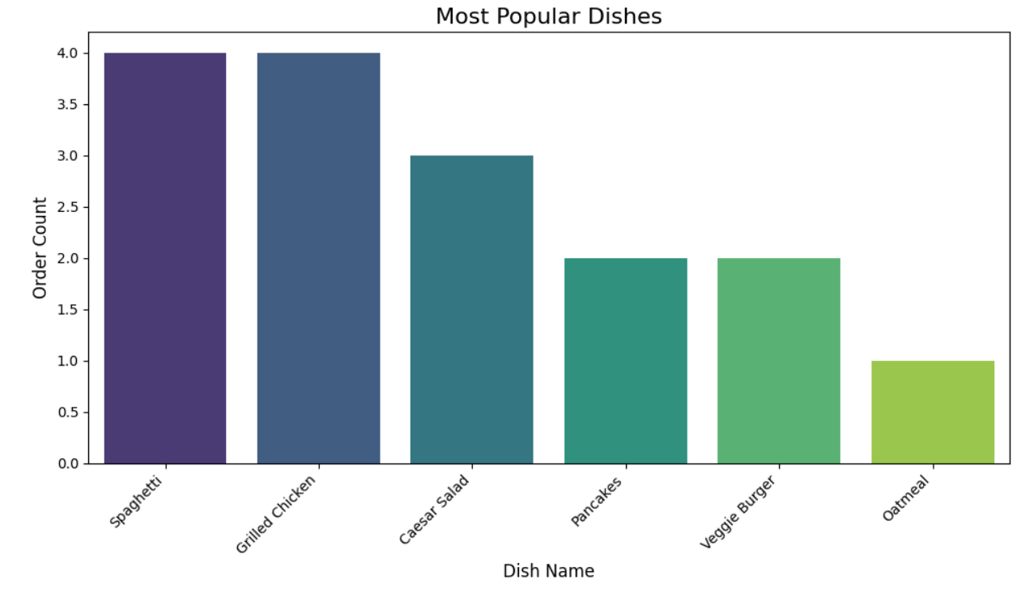

* **Top Dishes by Revenue**:
  + *Grilled Chicken* generated the highest revenue, followed by *Spaghetti*.
  + These dishes are commonly ordered during dinner sessions.

**2. Relationship Between Cooking Sessions and Orders**

* Users who participated in cooking sessions rated their orders higher on average (≥4 stars).
* The majority of cooking sessions aligned with dinner orders, suggesting a strong link between evening engagement and order placement.
* Longer cooking sessions (30+ minutes) were associated with higher user ratings and increased order amounts.  
  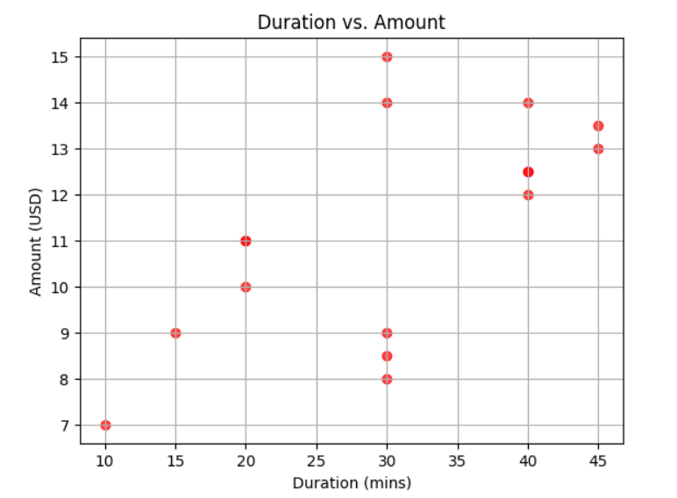

**3. Demographic Insights**

* **Age**:
  + Younger users (25–30) are more likely to order frequently and participate in cooking sessions.
  + Older users (35+) tend to prefer breakfast and lunch sessions.

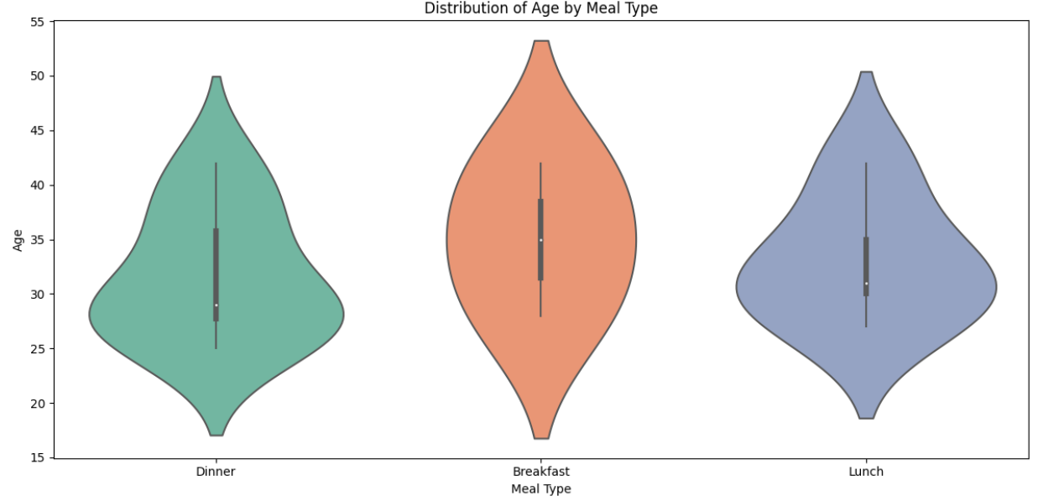

* **Location**:
  + Users in urban locations like New York and Los Angeles have higher order frequencies.

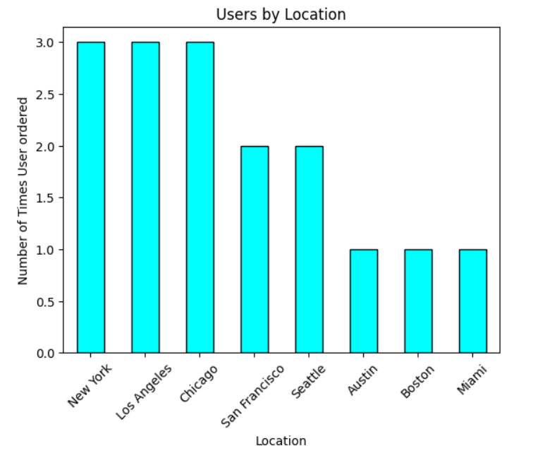

* + Chicago and Seattle users display a preference for breakfast orders, correlating with their "Favorite Meal" preferences.

**4. Session Duration and Rating Correlation**

* Sessions lasting between 30 and 40 minutes receive higher ratings (≥4 stars).
* Shorter sessions (<20 minutes) correspond to lower user satisfaction and fewer orders.

**Recommendations**

1. **Enhance Engagement During Dinner Sessions**:
   * Introduce promotional offers on popular dishes like *Grilled Chicken* and *Spaghetti* to further boost dinner revenue.
2. **Target Younger Demographics**:
   * Leverage social media campaigns aimed at users aged 25–30, focusing on lunch and dinner sessions.
3. **Optimize Breakfast Menu**:
   * Expand breakfast options and promote them to users aged 35+ in locations like Chicago and Seattle.
   * You can add notifications and promotions targeting this age group in these cities.
4. **Improve User Retention**:
   * Encourage participation in cooking sessions to drive higher order ratings and repeat business.
   * Offer discounts or loyalty points for users engaging in longer cooking sessions.
5. **Location-Specific Strategies**:
   * Implement targeted campaigns in urban centers like New York and Los Angeles to capitalize on higher order frequencies.